Experiment with Deep Neural Network

At this area of Machine Learning we have chosen supervised learning.

Step 1. We must prepare labeled datasets, that contains of directories with images (charge density diagram in our case). Each directory must contain of the images with same characteristics. We prepared 2 directories Class1/... and Class2/... For better results the directories must comprise more than 1000 samples....

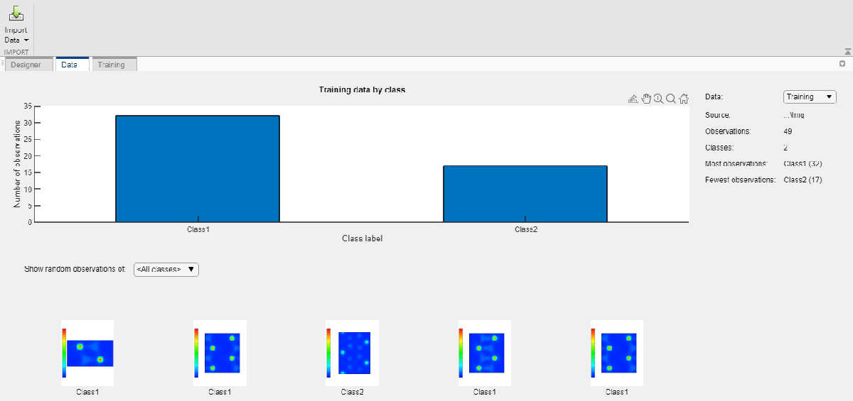

Step 2. We used a pretrained Deep Neural Network from deepNetworkDesigner toolbox.

deepNetworkDesigner

Choose an InceptionV3 (install it if not installed)

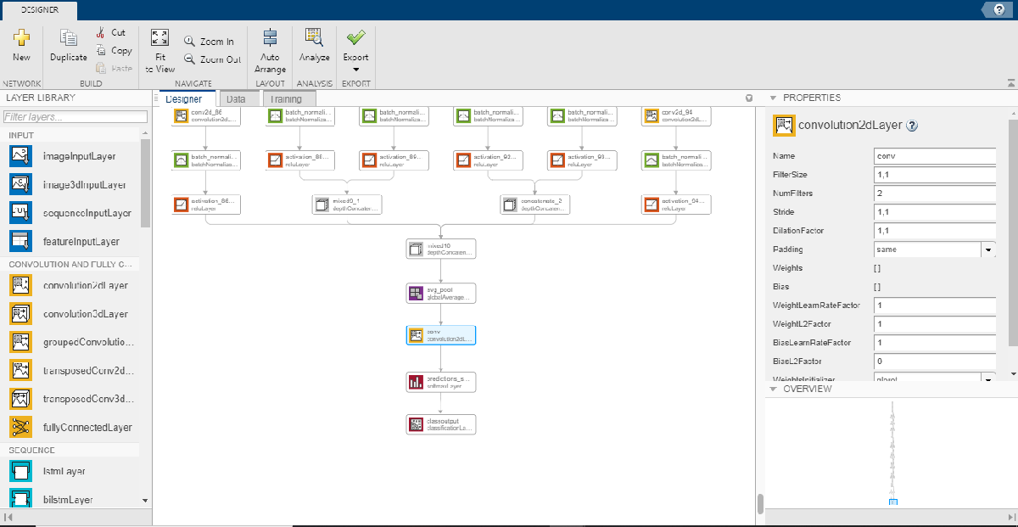

Step 3. Change the last fully connected layer (third before the end) and correct properties (Filter Size = 1,1 and NumFilters = 2) to agree with output classifier.

Step 4. Change and reconnect the last classifier layer to be auto tuned.

Step 5. Tune the training options.

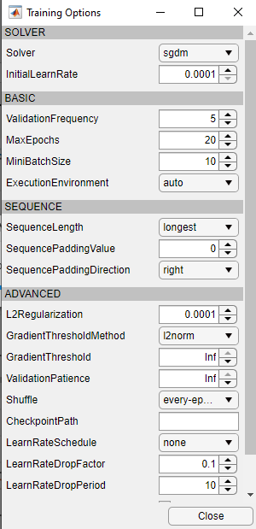

Step 6. Train and Export network as trainedNetwork_1

We can see a training progress as follows.

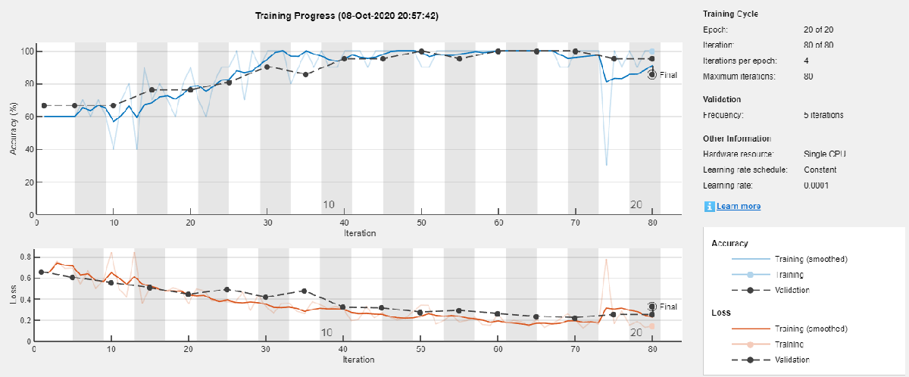

Step 7. Rename and save a trained CNN

net1_inception_2_class = trainedNetwork_1

save net1_inception_2_class

Step 8. We can make a test classification by using a test images.

Suppose the first test image has a " test1.tif " name

We must load, resize it for proper input and classify:

I = imread('test1.tif');

sz = net1_inception_2_class.Layers(1).InputSize

I = I(1:sz(1),1:sz(2),1:sz(3));

label = classify(net1_inception_2_class, I)

For example the file test1.tif is shown below:

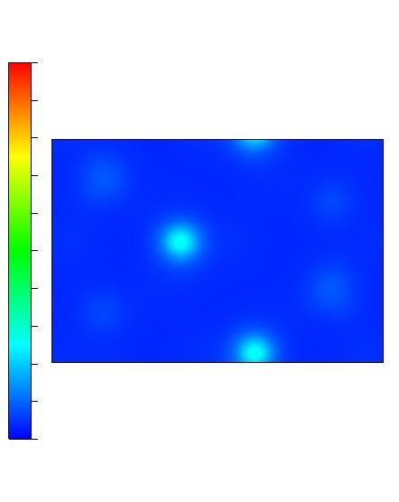

you can see the following output

label =

categorical

Class2

In means that loaded image is classified by CNN as Class2 image. The name of Class depends on previously trained data

**So we have classified an charge density image by Deep CNN**